Virtual Assistant
Training Guide

This book is a step-by-step guide for New Virtual Assistants. In it, we will cover every aspect of becoming a VA for [Your Company Name]. We’ll cover setting up office, communication with your employer, locating motivated sellers, marketing properties, submitting leads and getting paid.

What type of business are we in?
We are a full-service real estate solutions provider. We provide homeowners alternative options to selling their house. We understand in this market there is an influx of properties and inventory which may take several months and sometimes over a year to sell. In this market, many homeowners do not have the time to wait for a buyer; therefore, our services provide alternative solutions to their real estate challenges.
We strive to be an alternative solution in helping them meet their current challenges. When possible, we eliminate the hassle of listing their property with a realtor. The homeowners we work with are concerned about one thing, getting their property sold FAST.
A few ways we differentiate ourselves from realtors are:

- There are no long binding Realtor contracts
- No high commissions to pay
- No “out of pocket” expenses like needed repairs and closing costs.
- We create a stress-free closing process.
- We provide a ‘win-win’ home purchase, often in as little as 7 to 10 days.

Requirements for our Virtual Assistants

There are certain requirements for our VA’s and they are as follows:
- You must have a computer (not older than 3 years).
- You must have excellent internet navigation skills.
- You must have MS Word and be proficient in typing (45WPM+)
- You must have basic knowledge of MS Excel
- You must have downloaded to your computer and workable headset
- You must have a reliable high speed internet connection
- You must be able to speak and write good English
- You must have good communication skills
- You must be able to work late night hours
- You must be reliable
- You must commit time to study our process
- You must be flexible to work part time or full time

Here are a few tips for working with Motivated Home Sellers and Property Owners
As a virtual assistant, you are looking for highly motivated home sellers. It is essential that they are motivated for the success of this business. There are many different reasons a homeowner may need to sell quickly. As a virtual assistant, one of your jobs will be to find out what their motivation is. The more motivated a person is, the more willing they will be to sell their home to us at a discount.
Key Motivating Factors are as follows:
- They are having a financial hardship and can no longer make their mortgage payments. An owner that is behind on payments is willing to negotiate because their property may slide into Foreclosure.
- They are getting divorced and would like to liquidate their jointly owned property. This is typically a couple’s most significant asset. Often this is the most stressful (and necessary) item to liquidate. In most cases, one spouse is left alone with the property. In dual-income families, one person alone is often not able to afford the mortgage payment.
- The house is vacant and has become a huge insurance liability to homeowners. They are in fear of the house being vandalized or someone trespassing and getting injured on their property. These homeowners are motivated to negotiate a quick sale.
- They are tired of being landlords. They are having been dealing with difficult tenants and continued problems with this rental property. These landlords are sick of the headaches and want to sell fast.
- They are relocating and need to sell promptly due to family or work relocation. Many times, homeowners in this situation don’t have many options because they need to sell quickly.
- Their house sat on the market and their listing agreement has expired. Their property was listed by a realtor, sat on the market and never sold. These homeowners are seeking alternative options for a quick sale.
- A family member has passed away and they inherit a property they can’t afford or don’t want. The best solution for unwanted properties like this example is for the heirs to sell the property quickly, because they may need the cash more than the stress of owing another property.
- We are not looking for listed properties please do not call listed properties by an agent
Set-up Procedures, Getting Ready for Work
- Have your computer set up and working online
- Make sure your high-speed internet connection is in working order
- Download the Skype program onto your computer and connect a headset
- Set up a Skype account (www.skype.com) with ‘Unlimited Country’ for the USA
- Create a Gmail Account (www.gmail.com) and notify us of your e-mail address. Try to use something with our company name inside of it.
- Setup a Pay Pal account (www.PayPal.com) to receive payment for your completed work unless you are working through a company we pay direct!
- Set-up a Google Doc. Spreadsheet to monitor your leads for a follow up system and invite us at (youremail@gmail.com) as a ‘collaborator’ to the spreadsheet. This will give us a real-time view of the work you are doing.
Using Our KPI Tracker and Appointment Sheet
We will invite you to a Google Doc Shared Sheet. This sheet is what you will use daily when you are working with us. There will be two sheets
- VA KPI Tracker: This is to help us track the performance of how you are doing and what we need to help you with to make you better.
- VA Appointment Sheet: This is for when you have a homeowner that wants to talk to use about selling their house. You will put all their information on this sheet, and you will also need to get some extra information for us after the call is over with the homeowner.

See Sample Sheets below!!

We will help you understand how to use it in our first meeting. .

VA KPI Tracker:
#1: Lead Count: The number of Leads you have been given Seller Name
#2: Leads Called: This is the number of Leads you called that day
#3: Leads Contacted: This is the number of homeowners you got to answer the phone
#4: Leads Not Interested: This is the homeowners that didn’t want to sell their house
#5: Appt Set: This is the number of homeowners you spoke to that wanted to talk to us

VA Appointment Sheet:
Everything in Blue is questions to get from the homeowner when you are on the phone with them. The Green section is the sites you will go to and get extra information for us.
#1: Go to the site ex: Zillow.com and put the property address in
#2: Look at the property details sheet to find the COMP or Comparable Sales Price
#3 Place the Avg Sales Price in the box under the site in the sheet
#4: You will also go to RentOMetter.com to find the avg Rents for that property
** Once An Appointment Is Set Email Use The Information Right Away **

VA KPI Tracker: (Sample)
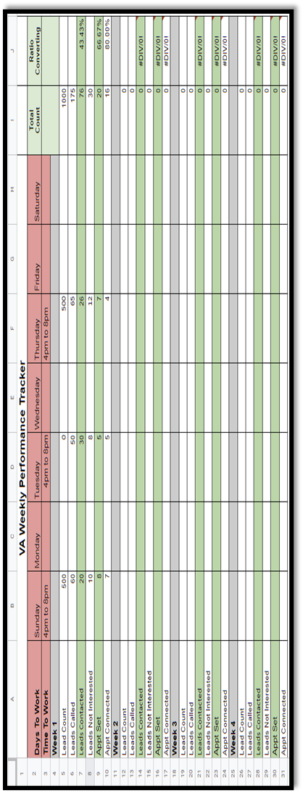
VA Appointment Tracker: (Sample)
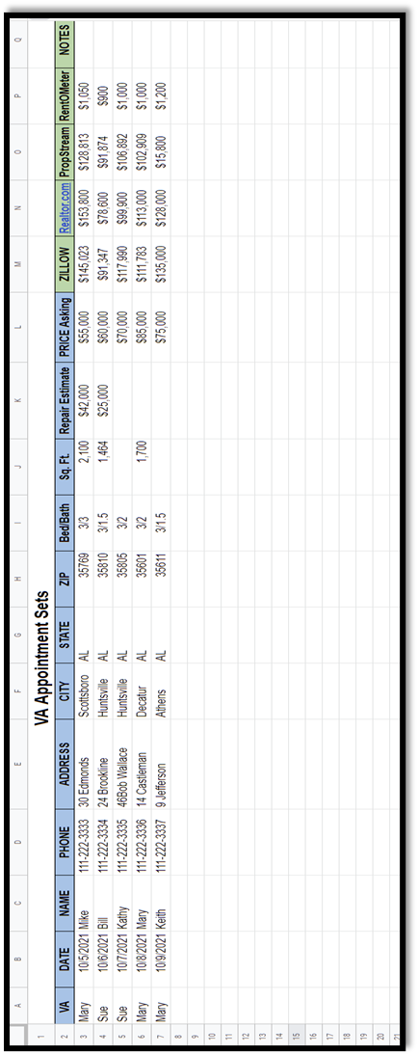
Outline of Work Schedule
Starting out, you must be available to work a minimum of ___________days per week. Your first sixty-days (60) are a probationary period. This is to ensure your performance meets our standards. After the probationary period, [Company Name] will provide you with a long-term employment agreement.
- Researching and Calling Leads to find properties for sale by homeowners; schedule is as follows (Your Time Zone):
  - Sunday: 4pm – 8pm (part-time)
  - Tuesday: 4pm – 8pm (part-time)
  - Thursday: 4pm – 8pm(part-time)

- You must copy and paste the qualified Ads from any seller sites you find homeowners that want to sell to a word document as you are researching the websites.

- Once you have completed your research print the word document with the ads you copy and pasted and proceed to the latter part of your workday which is scheduled below for you.

- You will also be responsible for Keeping up with your KPI Tracking sheet and your Appointment Sheet.

- You must input all the leads you found and called onto the Google spreadsheet that you set up earlier; this will be your tracking system that our Company will be able to monitor.

- You will also need to put the name, subject property address, home owner’s e-mail address, phone number, fax number, call log, and status update on the Google spreadsheet for any appointments made. You must keep up with this spreadsheet

- You will have a quota of 100 calls to be made per day. If this quota is not met, you will have a strike on your probation period.

- When calling a seller refer to the section titled “Calling Seller for a script”

Finding Sellers

As you start to do your business with us, one of the key components of your description of work is to find sellers who are selling real estate and be motivated for selling. What you will want to do is go to several websites looking for these seller leads (a list of websites on the next page). When you go to one of these sites, you will see all of them are different, but they all follow the same process. Typically, it is going to ask you what area/what location you are looking for. When you go there, you are going to want to make sure that you go into the area that says, “Buying a House” or “Looking to Buy a House.” In that area, you can put in your description of what you are looking for, or you can be very vague and just search all properties in a specific city, state, or location based on the information that we tell you what we are looking for.

You will also want to be cautious about price range. Most of the time our price ranges are going to be between $20,000 and roughly $300,000 to $400,000. Key words are very important also and they are going to give you the signs of the motivation such as “Must Sell,” “Need to Sell,” and “Handyman Special” (there is a list of keywords on the next page).

Now, the one thing that is very important is that we are not looking for listed properties. We are only looking at properties that are called For Sale By Owner. This is where an individual is trying to sell the property. We do not want you calling or researching listed properties.

REI Lead Bot

The Free Lead Generator is a tool that can help you start to manage your time better and automate a lot of the searching for some of these websites we give you. The way the REI Lead Bot works is it is an RSS reader that creates an open read to the website based on keywords that you put into the reader to look for (use the keywords on the keyword sheet on the next page). Those keywords are entered in and then they are connected to the site looking for anyone who has placed an ad for someone to buy their property with those keywords in it.

Now, the setup of this system is easily followed through a training system that we have put in place for you to watch for part of our training series.

- www.REILeadBot.com

Tip: Ideally you want to find motivated homeowners that have a good amount of equity in the property (equity is the difference between the market value of the property and the amount the owner owes on his/her mortgage), and needs to sell as soon as possible. We can help people in circumstances like these because we can close fast, and we provide easy solutions to their challenges.
Here are a few Websites in which you can find Motivated Sellers. (Some My Not Be Working)
www.Craiglist.com  www.Kijiji.com  www.ForSaleByOwner.com  www.SaleByOwner.com  www.FSBO.com  www.FSBOAmerica.com  www.FSBO.NET  www.ForSaleByOwnerCenter.com  www.FSBOAdvertisingService.com  www.Oodle.com  www.Vast.com  www.BackPage.com  www.OwnerWillCarry.com  www.Trulia.com  www.AllTheListings.com  www.Pages.EBay.com/RealEstate | www.PropertySites.com  www.Postlets.com  www.PropSmart.com  www.JustListed.com  www.NationalHomeSearch.com  www.RealEstate.com  www.PostYourPoperty.com  www.NewHomeSource.com  www.CityCribs.com  www.RealEstateAdvisor.com  www.HomePortfolioJunction.com  www.HomeEscape.com  www.HotPads.com  www.SoldByOwner.com  www.LiveDeal.com  www.PostYourPad.com

Here are a few “Key Words” and “Phrases” to look for when determining whether a seller is motivated
- Motivated Seller  - Divorce  - Must Sell  - Need to Sell  - Transfer / New Job  - Foreclosure  - Bankrupt  - Probate  - Desperate  - Can’t afford  - Fire Sale  - Handyman Special  - Fixer Upper  - Sell Fast | - Time is running out  - Moving  - Will sacrifice  - Owner transferred  - Will consider all offers  - Retiring  - Distressed sale  - Below appraisal  - Price below market  - Divorce situation  - Corporate owned  - Estate Sale  - As-is Condition  - Sold as-is, Where-Is

The ad must have one of these keywords in the advertisement for the lead to be considered a good lead. All good leads get paid. Remember, no Realtor leads, because we like to deal directly with homeowners.

Calling Sellers

One of your job criteria may be that when a lead comes in and after you have researched your leads, is to call these leads as a Tier 1 information call. To do that, you will have a script to follow which is on the next page. It gives you detailed information on what to say when you are calling these sellers. It is important that you listen to the seller, and if they say yes or no to a specific section of this script, you will have a statement to follow.

The important part about this is that you want to make sure that your asking the right questions when they are able to give you the information. Now, when you are following the script, when it is time to get the information, if we are providing you with a website to enter that information in, you will just want to follow the link given for you to ask the questions to the seller to fill in that form. If there is no website given to you, then you will simply want to use the Google Doc Sheet that you created with the list of columns as questions for you when you are on the phone with the seller. Those questions will be the following:

- The Seller’s Name?
- The Seller’s Phone Number?
- The Seller’s Email?
- The Property Address?
- The City & State?
- The Property Bedroom Count?
- The Property Bathroom Count?
- The Property Square Footage?
- Does the property need repairs?
- Is it listed?
- How much are they asking for the property?

These are series of questions that you will want to ask moving forward. You can also use the Google Doc Sheet to enter this information in once you have asked the questions to the seller.

APPENDIX A
Phone Script when Calling Homeowners

Hello __________ (Property Owner), my name is _____________ (Caller). I am calling from (Your Company Name Here) a full-service Real Estate Solutions provider. We are interested in purchasing your property, and we want to know if it is available for sale.
If the seller asks how, you received their information let them know that you found the property through a website in which they posted it.
We are not Realtors. We service homeowners throughout the nation giving them an alternative way of selling their house without the hassles of listing with a realtor and without commissions or fees. We can typically close within 7 days.
If they say yes:
Great; is this a good time to speak with you? Do you mind if I ask you a few questions about your property so I can see if the property meets our criteria for purchase?
If the owner says yes.
Fill-out as much information as you can on our website (Your URL Here) or on the VA Appointment Set sheet on the Google Drive. Then, let them know that you will be running a market analysis on the property to see if the property meets our criteria for purchase. A property specialist will be contacting them within 24 to 48 hours.
If they say no:
Ask them for an e-mail address and/or mailing address to send them some information on our company if they decide to sell any time in the future.
If the answering machine picks up:
Hi, this message if for ________ (Owner); my name is ___________ (Caller). I am calling from (Company Name) regarding property address __________________ (if there is no address just tell them the city where the property is located). We are interested in purchasing the property, and we want to know if it is available for sale. Please call (Your live answering service 1-800 number) to learn more about how we can buy your house.

**** If you Don’t have a 1-800 # let us know we can help with some companies we use****

*** If there is no website then remember to ask the question listed on the previous page**

APPENDIX A
Email Script When Email Homeowners and Landlords

Email Script to Send Out to Homeowners

When send out an email for first contact

- Hello, I saw your property and wanted to know if it was still for sale?
- If it is I would be interested in asking you a few questions about it?
- I am interested in making an offer on your house!
- When can we talk about your property?

Email Script to Send Out to Landlords

When sending out an email for first contact

- Hello, I saw your property for rent and wanted to know if it was still for rent?
- Also, I wanted to see if you might be interested in selling it or any other property you have?
- If you are interested in selling, I would like to ask you a few more questions about the property before making an offer.
- When can we talk about your property?

*** IMPORTANT NOTE***
Make sure the VA lets the HO know that they are not realtors

Analyzing Leads

In the Analyzing Leads section of your work criteria is basically broken into two parts.

Option 1, if we have sent you spreadsheets, you will simply want to take the information that you received from the seller and fill out the spreadsheet in the boxes that are necessary. It is ok if it is not all complete. Once you have filled out that spreadsheet on each property, you will want to email that spreadsheet to [your company email].

Option 2 is if there are no spreadsheets given to you, then you will simply make sure that you fill in the information on the Google Docs Sheet with all the details given by the seller. Once that has been done each day, you will want to email us an updated email that there are new leads in the spreadsheet for us to go evaluate.

Sending an Offer

In some cases, it will be ok for you to send offers out. If we give you that permission, we will give you a form which is known as a LOI (Letter of Intent) that you will be able to use. Through this process, you will send an offer through email. You will make sure that you use the Google email that you set up based on our company.

When a seller is requesting an offer or we give you a specific discount to make the offer at, typically that discount is going to be 60% of the estimated value of the property (you can find this estimated value from Zillow.com or CyberHomes.com).

Then that offer will be filled out through that one page (Letter of Intent), and you will send that offer out as an email to the seller with the intent of them to accept our Letter of Intent. Now, once that Letter of Intent has been emailed back to you fully executed, you will want to send that to us through email to let us know that we have a seller of a property that is interested in us buying it.

Submitting Leads

When it is time to start submitting leads to our company, you are going to want to look at a couple of different ways. One way that I want to point out is if we give you no website, then you want to follow the same protocol as in “Calling Sellers.” In that protocol, we talked about the different ways of submitting leads there also. One was through the Google Docs Sheet; putting the information into the Google Docs Sheet and notifying us that the lead is available.

The other way is if we give you a website. What you will want to do is when you follow our website questions and you want to submit leads into us through our website, you will simply follow the protocol listed below.

Submitting Leads With A Website
Step 1: Go to our website at (Your website goes here)
Step 2: Input the homeowners’ information on the “instant cash offer now” section of the website and notify the homeowner that a property specialist will be contacting the homeowner within 24 to 48 hours; this will give us enough time for us to do a market analysis. (See appendix A for the script when contacting a lead)
*** If you don’t have a website that will allow you to get homeowners information than email www.LocalInvestorWebsites.com and we can help you. ******
Step 3: Put your initials on the notes section of the questionnaire so we know who the lead came from.
Step 4: Request an e-mail address and fax number of homeowners.
Step5: Request the homeowner to e-mail us pictures of the property and any inspections and/or appraisals they may have. Have them put the address of the property in the subject line of the email.

Marketing a property

As you move through the process of a seller and you have gathered all of their information, the offers have been sent, and it has been analyzed; then there will come a point when you start marketing a property. The marketing of a property falls into two different processes.

Step # 1: If the seller accepts an offer that you sent out to them through email or through the Automated Deal Maker online offering system, then you will be notified that the seller has accepted these offers. When they do that, you will want to follow the selling process listed below. You will only follow that process after the seller has sent you an offer that has been signed.

Step # 2: In some cases, we will send you a lead that needs to be marketed to the Web for a buyer, and you will also want to follow the selling process listed below.

Selling Process

When it comes time to sell the property, we will sometimes depend on you to help bring a buyer in on the deal. To do that, there are a couple of things that you can do to support the company in finding a buyer for one of our leads.

The number one thing that you can do is build a property flyer. To do that, you can VFlyer.com (VFlyer.com is only active if we turn it on. It is a paid website).

Once you go to a site like VFlyer.com, you will go to their main site, and you will create your listing by clicking on the button that says “Get Started.” Once you are in there, you will want to make sure that you give the property a title. Typically the titles can be the address of the property or it can also be a catchy title like “Must Sell This Home,” “Need To Sell This Home,” “Great Deal,” “Must See,” “Won’t Last Long,” or “My Loss, Your Gain.” Those are great titles to put on the flyer.

You will also want to make sure that you put in the bedroom types, the bathroom types, the square footage types, the parking if there is any, the pet policy, deposits, and so forth, what the price will be, and a description of the property that the seller has given you.

You will also want to make sure that you have pictures of the property to put into the flyer (to acquire pictures, when you are talking with the seller, you are going to request that they send you pictures of the property to the Google email account that has been provided for you).

The pictures are very important to put into the property because it gives us a future buyer the ability to see what they might be buying.

The other thing is that you want to include features like if it is on a cul-de-sac, if it is on water, if it has a pool, if it has been updated, and so forth. Contact information will also need to go into this flyer. The contact information is going to be our company information and it could also be an email address that we give you or it could be the email address that you are using for us as a company to be able to notify us anytime a buyer has came to you, look at our flyer, or is interested in our property. You will also want to give a direct phone number to our company (company phone number).

This same process will also be used in the VFlyer.com flyer situation. Once you have a flyer created, you will then want to post that flyer in other websites listed below.

Another key feature that we will want you to do is sign up for group sites like as in Groups.Google.com, Groups.MSN.com, Groups.AOL.com, Groups.MySpace.com, and there are other group sites out there that you can search out on your own. When it comes time to set up a Google Group site, one of the things that you are going to want to do is when you are there; you are going to want to search for the keywords relevant to what you are looking for: real estate, real estate properties, real estate investing, and real estate investors. What you are going to do is search by region. Typically the United States is a good region. Then you will be able to search by members. We are typically looking for groups that have 10 to 1,000 members. When it comes time to join them, you will want to join them with the email address given to you by our company which will be a Gmail account.

Now, once you have these Google Groups and MSN Group pages ready to go, you will be given an email address to that group to email them anytime you want to make a post. Through that process, you will email them the link to your flyer or if you do not have a flyer, send them information about a property that we are trying to sell. You want to make sure that you put the same contact information on there if they are interested in it.

Another source of marketing could be through our database which is also our CRM system (Client Relations Management System). To send emails out to our database buyers, you will need to have log in information from us, and training on how and which group to email to.

Now, as the buyers start to come in and they start to respond to you if you are filling in these buyer’s information, you will just want to let each buyer know that we have their information and that we will be reaching back out to them before you email us the buyer’s information.

The other thing that you might want to be prepared for is if a buyer is ready and willing to buy the property, you will also want to send them an Assignment Agreement [all documents will be sent from our office to you that is required to do your job] for them to fill out and send back to you being prepared to buy the property.

If you get multiple buyers, you need to let the buyers know as they come in, if no one has sent you a signed Assignment Agreement in yet, then you will let each buyer know that they are in first position right now, but once a buyer sends you a signed Assignment Agreement, then you will let the previous buyers know that they are in second or third position and send them an Assignment Agreement also, and have them fill it out just in case the first buyer does not close.

*** See sample Flyer here ****

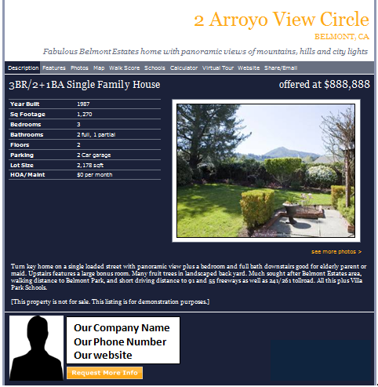

Coordinating the Close of the Real Estate Transaction

One of the processes that you will learn to do and you will start to support the company in is supporting the coordination of the closing in the real estate deals. Your support is going to be communicating with a Virtual Closing Coordinator Company that our company will supply to you with contact information.

One of the things that you will want to find out from our company is the process that our Virtual Closing Coordinating Company will want, and the information that they will want. One of the things that they will require is seller paperwork. This paperwork is the paperwork that the seller signed off on being contracts and so forth agreeing to sell us the property. They will also want your buyer’s paperwork. The buyer’s paperwork is simply going to be the Assignment Agreement that the buyer signed off on.

You will want to make sure that you send the Virtual Closing Coordinator Company both agreements with contact information to the seller and contact information to the buyer and our contact information here at the main office.

The other scenario that you may run into is your backup buyers. So, if the first transaction does not go through, the Virtual Closing Coordinating Company lets us know that the buyer does not qualify, it would be a high responsibility for you to email the second or the third or the fourth buyer and let them know that the first buyer fell out to get their information with their signed agreement over to the Virtual Closing Coordinating Company.

Compensation, How you get PAID!!
See Appendix B, VA Servicing Agreement

Now You Are Ready To Get Started Finding Motivated Sellers?
With the above information you should have all of the tools you need to get started on locating properties owned by motivated sellers. The biggest threat to your success at this point is not to take action. If you have questions about anything in this guide, please e-mail us at any time at (Your e-mail address here)

APPENDIX B
(Your Company Name Here)

This Service Agreement (the "Agreement"), made and entered into as of this _____ day of ___________, __________ by and between (Your Company Name Here) hereinafter” (Your Company Abbreviations Here) and Virtual Assistant, (Your VA’s Full Name Here) (hereinafter "VA").

service agreement

This Service Agreement made on this ____ day of __________ between Virtual Assistant (VA) ______________________ (VA’s Full Name Here) and (Your Company Name Here) (Your Company Abbreviations Here) having its place of business operation at (Company Address). In this agreement, the company who is contracting to receive the services shall be referred to as (Your Company Abbreviations Here) and the service provider who will be providing services shall be referred to as “VA”.
Background
- (Your Company Abbreviations Here) is of the opinion that the VA has the necessary qualifications, experience, and abilities to find properties through the internet, contact the leads and complete the questionnaire.
- The VA is agreeable to providing such services to (Your Company Abbreviations Here), on the terms and condition as set out in this Agreement.

IN CONSIDERATION OF the matters described above and of the mutual benefits and obligations set forth in this agreement, the receipt and sufficiency of which consideration is hereby acknowledged, the parties to this agreement agree as follows:
Services
Starting on (Date you will start VA’s Services) the VA will provide the following services:
- Researching and Calling Leads to find properties for sale by homeowners; schedule is as follows (Your Time Zone):
  - Sunday: 4pm – 8pm (part-time)
  - Tuesday: 4pm – 8pm (part-time)
  - Thursday: 4pm – 8pm(part-time)

- You must copy and paste the qualified Ads from any seller sites you find homeowners that want to sell to a word document as you are researching the websites.

- Once you have completed your research print the word document with the ads you copy and pasted and proceed to the latter part of your workday which is scheduled below for you.

- You will also be responsible for Keeping up with your KPI Tracking sheet and your Appointment Sheet.

- You must input all the leads you found and called onto the Google spreadsheet that you set up earlier; this will be your tracking system that our Company will be able to monitor.

- You will also need to put the name, subject property address, home owner’s e-mail address, phone number, fax number, call log, and status update on the Google spreadsheet for any appointments made. You must keep up with this spreadsheet

- You will have a quota of 100 calls to be made per day. If this quota is not met, you will have a strike on your probation period.

- When calling a seller refer to the section titled “Calling Seller for a script”

Payment Terms
- (Your Company Abbreviations Here) will make payments to the VA for services based on $________ per hour. This compensation shall be payable on a bi-weekly basis via the VA’s PayPal account. The VA must provide an invoice on a bi-weekly basis to receive compensation, and VA must meet quota set forth by (Your Company Abbreviations Here) and this agreement to receive compensation.
- (Your Company Abbreviations Here) will reimburse the VA for charges by Skype for calls made for the purpose of (Your Company Abbreviations Here) calls ONLY. The VA must provide (Your Company Abbreviations Here) with breakdown of charges on a bi-weekly basis in order to be reimbursed (a copy of the bill).

Termination
- Either side upon ten (10) days written notice may terminate this agreement.

Terms of the Agreement
- The term of this Agreement will begin on the date of this Agreement and will remain in full force and will stay in effect until cancelled in writing by either party.

(YOUR COMPANY ABBRIVIATIONS HERE) Commitments
- (Your Company Abbreviations Here) Agrees to reimburse the VA for charges on Skype on a bi-weekly basis for calls made for (Your Company Abbreviations Here) purpose only by means of PayPal
- After 2 month probationary period is complete, and if (Your Company Abbreviations Here) decides to continue with services provided by the VA his/her performance will be assessed for increase in compensation.
- (Your Company Abbreviations Here) agrees to pay the VA for 8 hours 3 days a week through the VA’s PayPal account on a bi-weekly basis as long as VA obtains quota disclosed in this agreement.

Requirements of Agreement
- All leads must be inputted into (Your Company Abbreviations Here) website the dates scheduled within this agreement.
- The VA will have a quota of 100 call per day in order to stay employeed.
- The VA will have 2 month probationary period for (Your Company Abbreviations Here)) to asses the VA’s services. (Your Company Abbreviations Here) will decide if the service provided by the VA is adequate for continuation of service.
- Both parties agree to do everything necessary to ensure that the terms of this agreement take effect.

Legal Expenses
- If legal action is brought to enforce or construe any term of this Agreement, the prevailing party will be entitled to recover, in addition to any other damages or award, all reasonable legal costs and fees associated with the action. A license arbitrator will be used.

Notice
- All notices, requests, demands or other communications required or permitted by the terms of this Agreement will be given in writing and either served personally, by email, by facsimile or by registered mail. The addresses for any notice to be delivered to any or the parties to this Agreement are as follows: (Your Company’s Mailing Address Here)
- Alternatively, to such other address as to which any party may from time to time notify the other.

Titles/Headings
- Headings are inserted for the convenience of the parties only and are not to be considered when interpreting this Agreement.

Gender
- Words in the singular mean the included the plural and vice versa. Words in the masculine mean and include the feminine and vice versa.

Confidentiality
- The VA acknowledges that a material term of the agreement with the (Your Company Abbreviations Here) is to keep all confidential information belonging to (Your Company Abbreviations Here) confidential and protect its release to the public. The VA agrees not to divulge, reveal, report or use, for any purpose, any confidential information which the VA has obtained, or which was disclosed to the VA by the (Your Company Abbreviations Here).

- The obligation to protect the confidentiality of the (Your Company Abbreviations Here) confidential information will survive the termination of this Agreement and will continue until such termination.

- The VA may disclose any of the confidential information:
  - To a third party where the (Your Company Abbreviations Here) has consented in writing to such disclosure; and signed a Landmark NCND.
  - To the extent required by law or by the request or requirement of any judicial, legislative, administrative, or other government body. However, the VA will first have given prompt notice to the (Your Company Abbreviations Here) of any possible or prospective order (or proceeding pursuant to which any order may result), and the Customer will have been afforded a reasonable opportunity to prevent or limit any disclosure.
- Any work copyrighted, patents, products or other information created in part by the VA in connection with the services shall be the exclusive materials of (Your Company Abbreviations Here).
- The VA will not at any time or in any manner either directly or indirectly use, disclose or communicate in any manner any information that is proprietary to (Your Company Abbreviations Here). The VA will keep strictly confidential such information. Upon termination of this agreement, the VA will return all materials that is maintained and used for (Your Company Abbreviations Here).

Assignment
- This Agreement is a personal one, being entered into in reliance upon and in consideration of the personal skill and qualifications of the VA. The Service Provider will not voluntarily or by operation of law assign or otherwise transfer the obligations incurred pursuant to the terms of this agreement without the prior written consent of the (Your Company Abbreviations Here).

Capacity/Independent Contractor
- It is expressly agreed that the VA is acting as an independent contractor and not as an employee in providing the services hereunder. The VA and (Your Company Abbreviations Here) acknowledge that this Agreement does not create a partnership or joint venture between them.
- It is clearly stated by either side that the VA is an independent service provider with respect to (Your Company Abbreviations Here) and not an employee of (Your Company Abbreviations Here), and (Your Company Abbreviations Here) will not provide any benefits to the VA.

Modification of Agreement
- Any amended or modification of this agreement or additional obligation assumed by either party in connection with this agreement will only be binding if evidenced in writing signed by each party or an authorized representative of each party.

Time of the Essence
- Time will be of the essence of this agreement and of every party hereof. No extension or variation of this agreement will operate as a waiver of this provision.

Entire Agreement
- It is agreed that there is no representation, warranty, collateral agreement or condition affecting this agreement except as expressed in it.

Severability
- In the event that any of the provisions of this agreement are held to be invalid or unenforceable in whole or in part, all other provisions will nevertheless continue to be valid and enforceable with the invalid or unenforceable parts severed from the remainder of this agreement.

Currency
- Unless otherwise provided for, all monetary amounts referred to herein will be paid in US dollars.

Governing Law
- It is the intention of the parties to this agreement that this agreement and the performance under this agreement, and all suits and special proceedings under this agreement, be construed in accordance with the governed, to the exclusion of the law of any other forum by the laws of the State of (Your State), without regard to the jurisdiction in which any action or special proceeding may be instituted.

Notice
BOTH PARTIES have signed this document on the day, the month, and year first above written.

In witness where of the parties have duly executed this Service

Agreement this ____ day of _________, __________

_______________________________
By: (Your Name Here, Title) By: Virtual Assistant/VA

Print Name: ______________________ Print Name: ______________________

You’re Company Name Here
You’re Company Address Here
You’re Company Phone Number Here

