Single Family Flip Opportunity
12662 Hutchins circle,
Madison, AL 35756

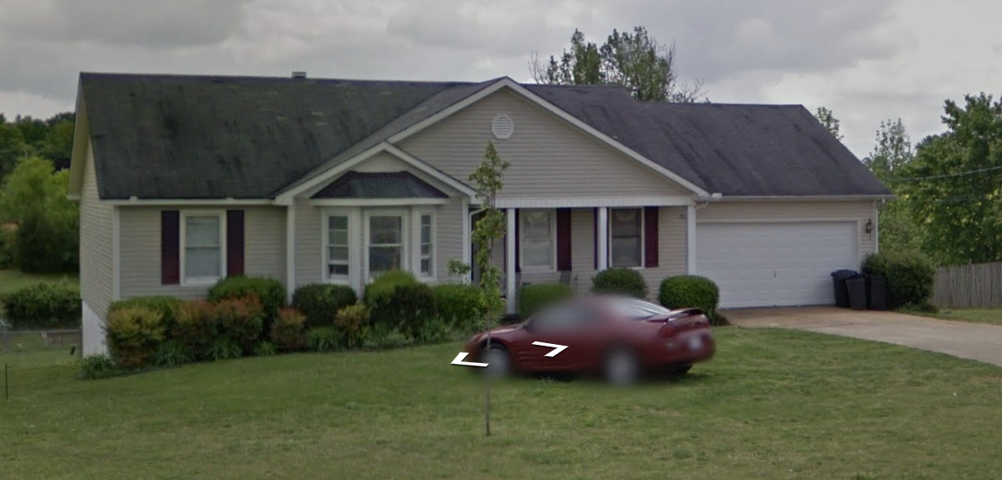
This is a Great house in a quite neighbor in the heart of Madison Al.
This property has vinyl siding, vinyl window and the roof has just been updated on the property.
The opportunity is we can turn 2 rooms in the basement into bedrooms by adding windows to meet egress! Which will increase the value of this property.
This property will need a full Rehab and landscaping!
There is a opportunity for our Lending Partner to make a great safe return on this deal in the heart of Madison Al.

This Deal Offering Is Presented By:
Landmark Property Investments LLC
Zack Childress
715 Arcadia Cir
Huntsville Al 35801
256-733-1412
Buyer@HuntsvilleHouseBuyer.com

Property Details:

Property Address: | 12662 Hutchins Cir
Property City, State: | Madison, AL
Property Type: | Single Family
Property Beds: | 3
Property Baths: | 3
Property Sq. Ft.: | 2317
Property Lot Size: | 26,365
Property Yr. Built: | 1997
Estimated Value Of Property: | $312,795
Raising Funds In The Amount: | $220,000
Terms Of The Deal: | 6% Interest / 6 Months

Property Description: This single family has it siting on one of the largest lots in this neighborhood and backs up to woods. This property has had a new roof put on it and the HVAC is only 4 years old. The windows are all vinyl and in great working condition. All interior doors are in great shape to keep. The properties 2 upstairs bathrooms are full baths, and the downstairs is a full bath. The house currently has hardwood floors in the up stairs and vinyl in the kitchen and bathrooms. The downstairs has carpet except in the bathrooms.

Property Project: This property will need a full paint job on the inside, new flooring in all wet areas (kitchen, baths, laundry) There is sheet rock work needed in this house, New lighting package and hardware package, all new plumbing fixtures, New back sliding door, new appliance package, new counter tops, new hand rail going to the basement, all new carpet downstairs, new sliding door downstairs, we will need to add 2 windows in the two rooms downstairs, update bathroom in basement. Exterior needs pressure washing, landscaping, back porch roof removed, restructure the porch, and fix the garage door.

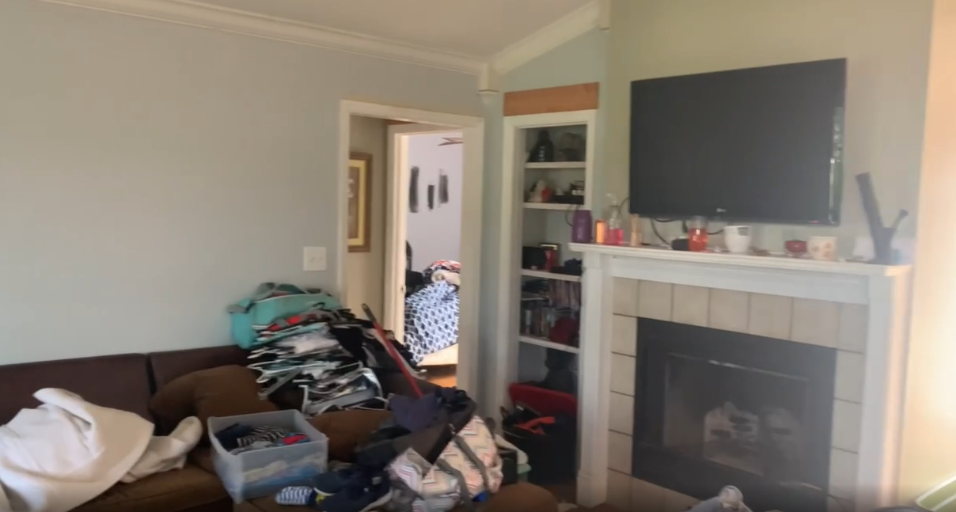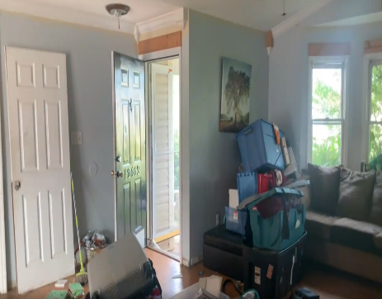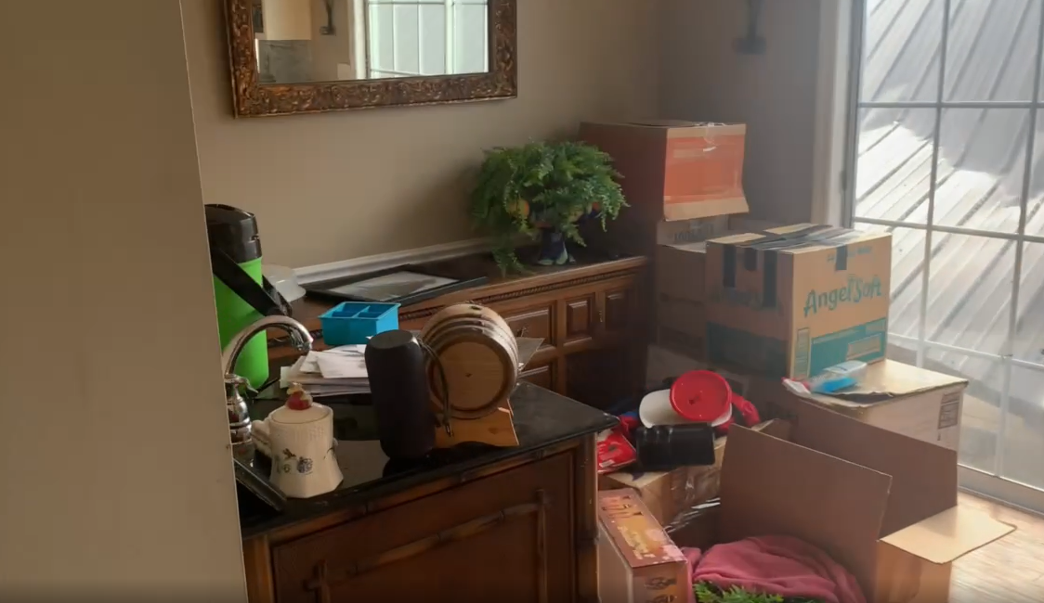
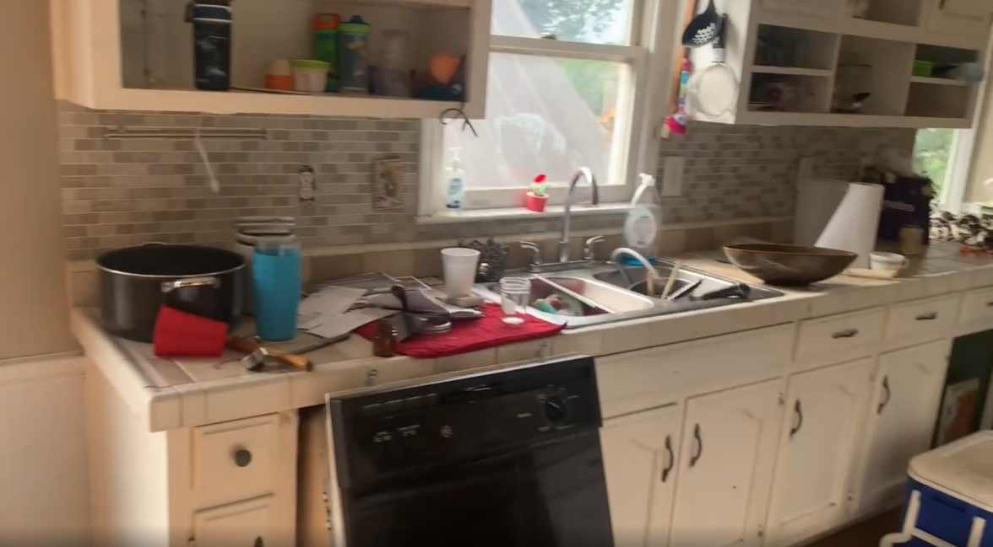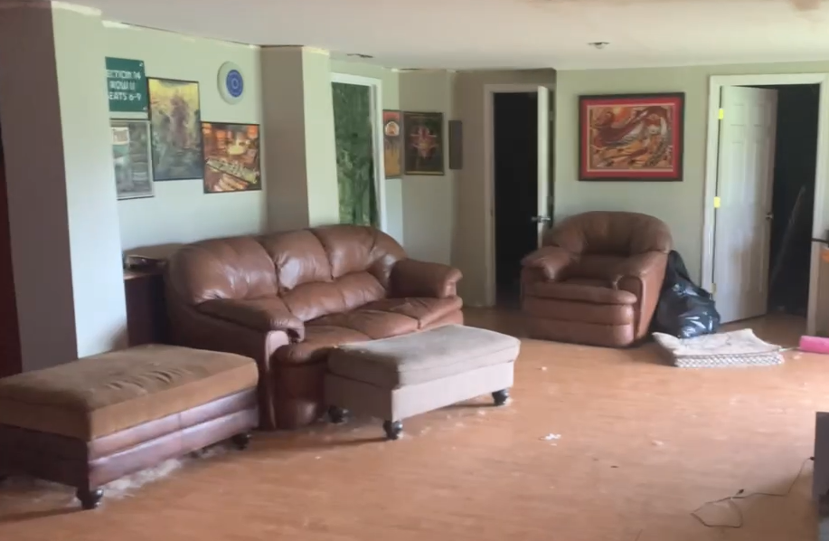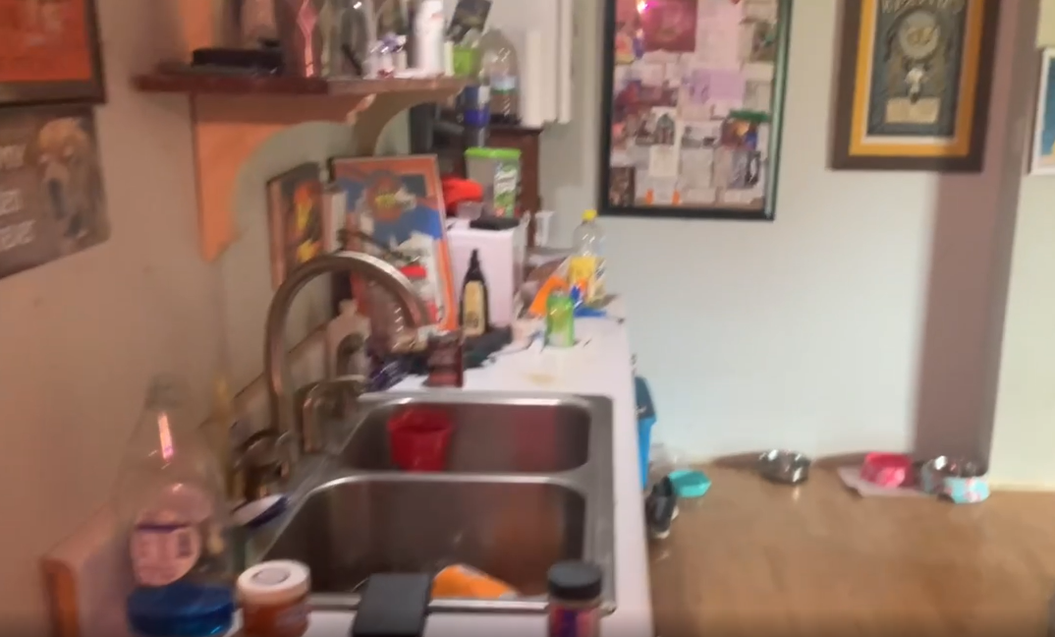
Property Flip Projection Sheet
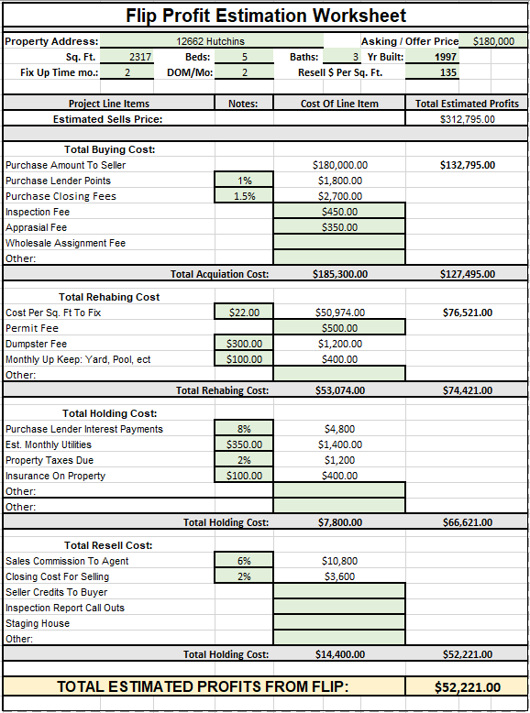

Property COCR Projection Sheet

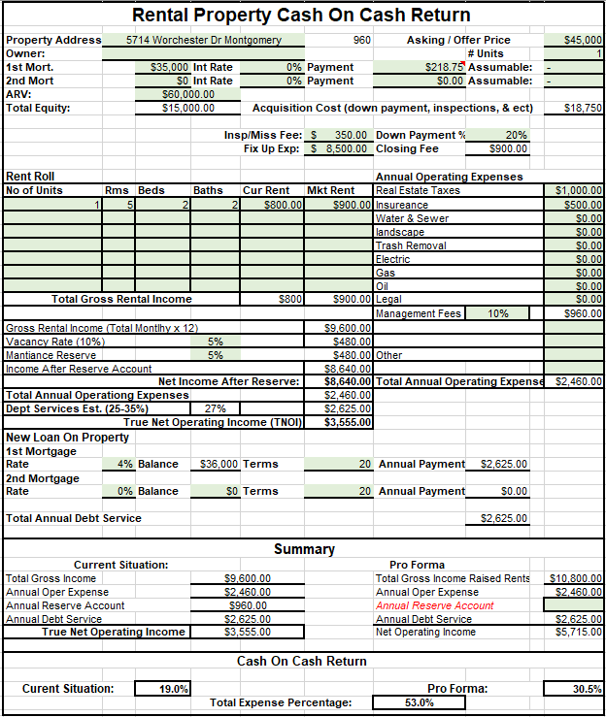

Comparable Sales Report

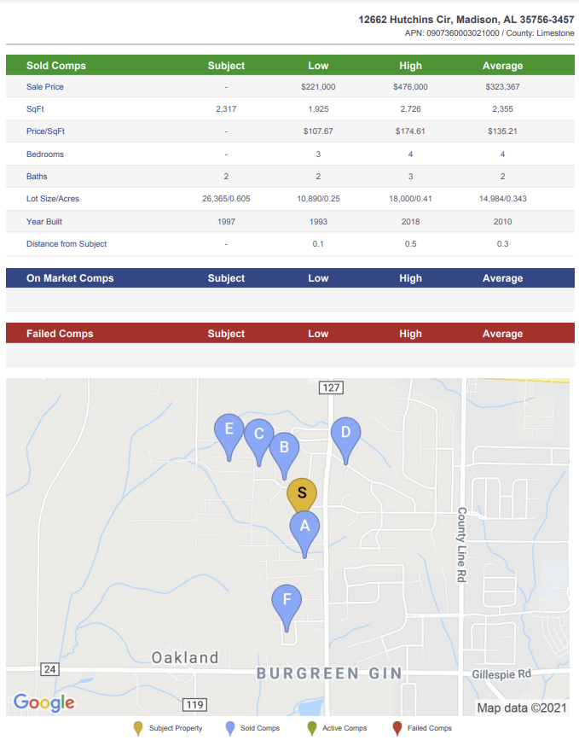
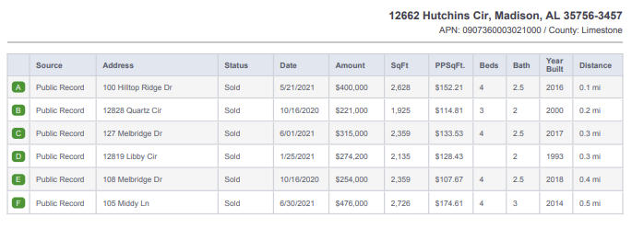
Comparable Rental Report

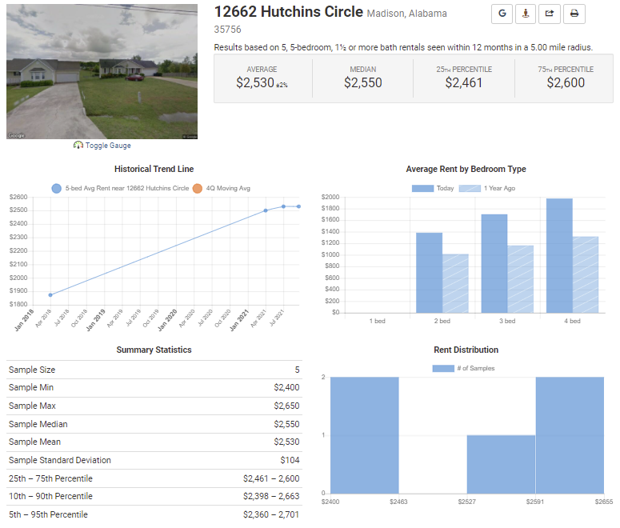
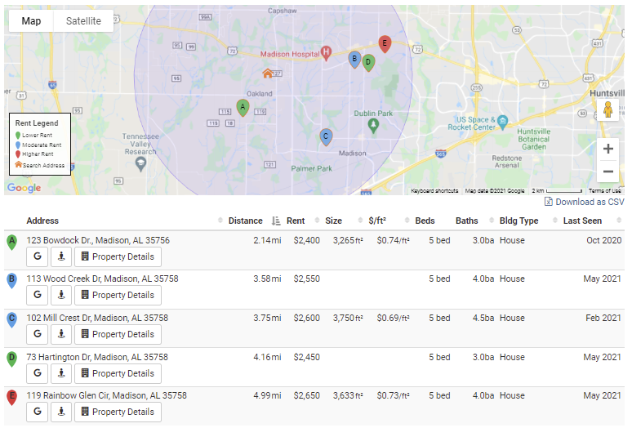
Property Location View

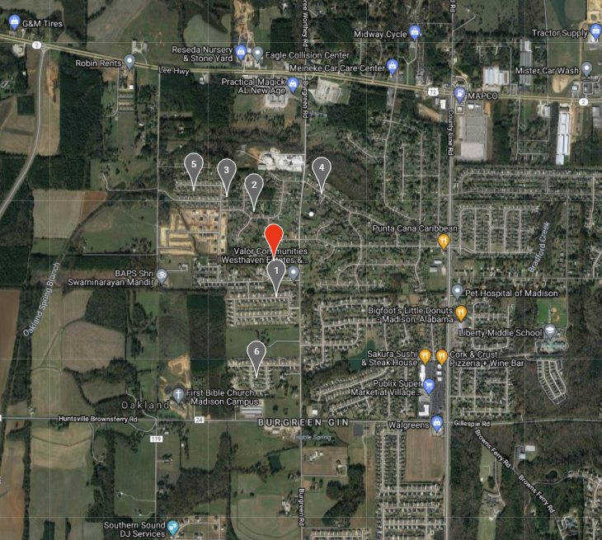

This Deal Offering Is Presented By:
Landmark Property Investments LLC
Zack Childress
715 Arcadia Cir
Huntsville Al 35801
256-733-1412
Buyer@HuntsvilleHouseBuyer.com

